- Click on the link to the Google developers site.
https://developers.google.com/maps/documentation/geocoding/get-api-key
- Select the Get Started button
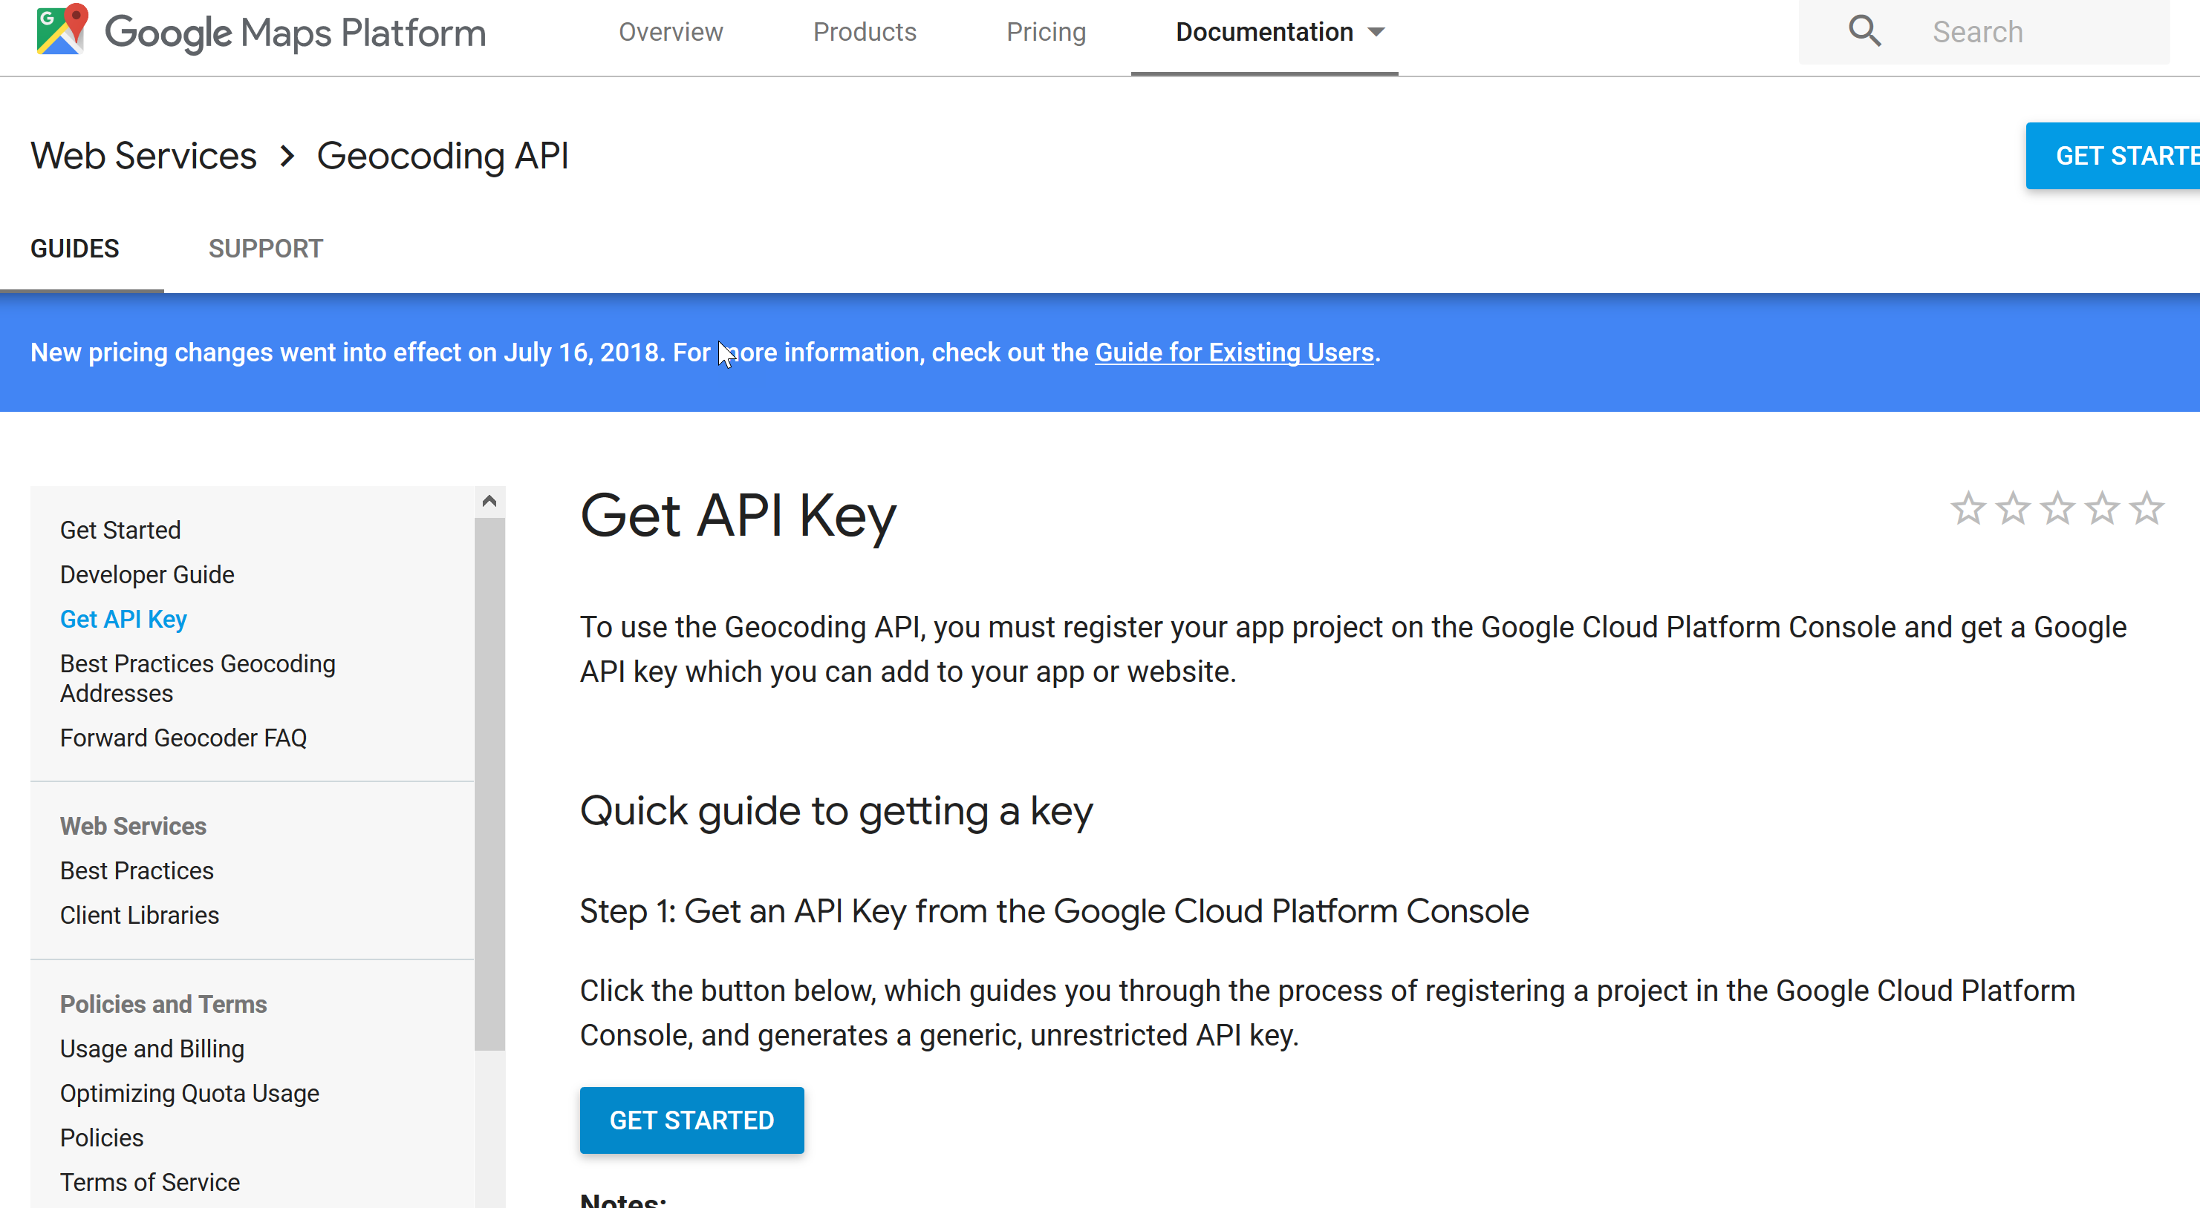
- If you are not already signed in to a google account, you will be prompted to sign in. If you have an account go to step 15.
- At the sign in page Select Create Account.
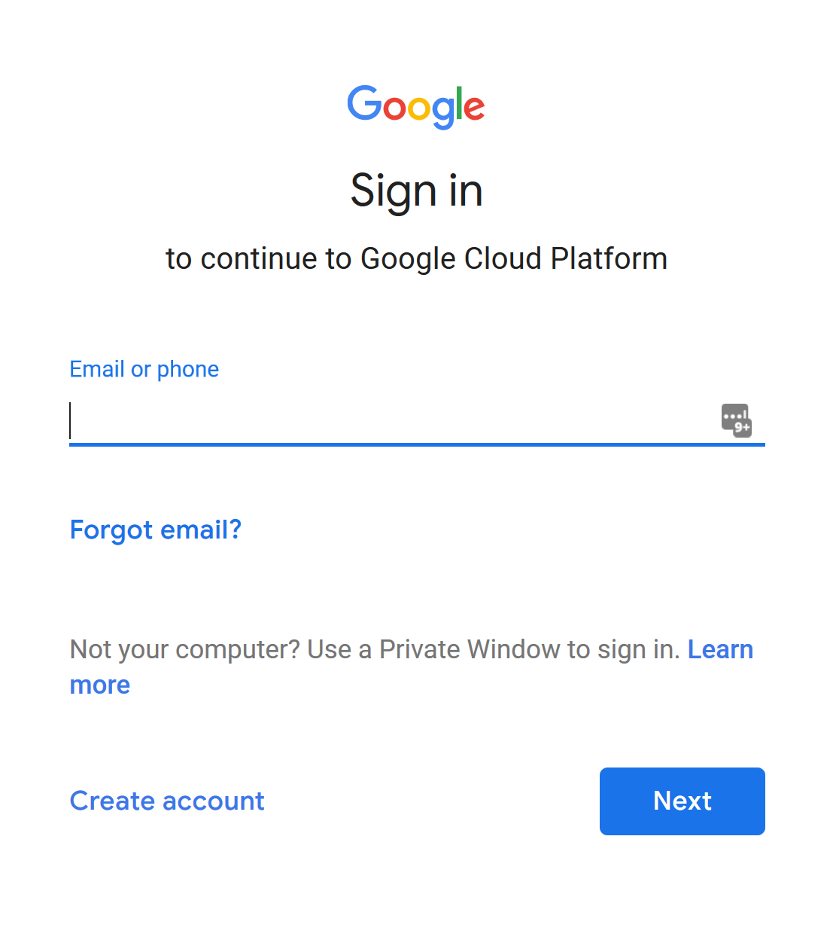
- Complete the dialog block with your email address you would like to associate with the account. You will need to have access to this account during the setup process. Select Next.
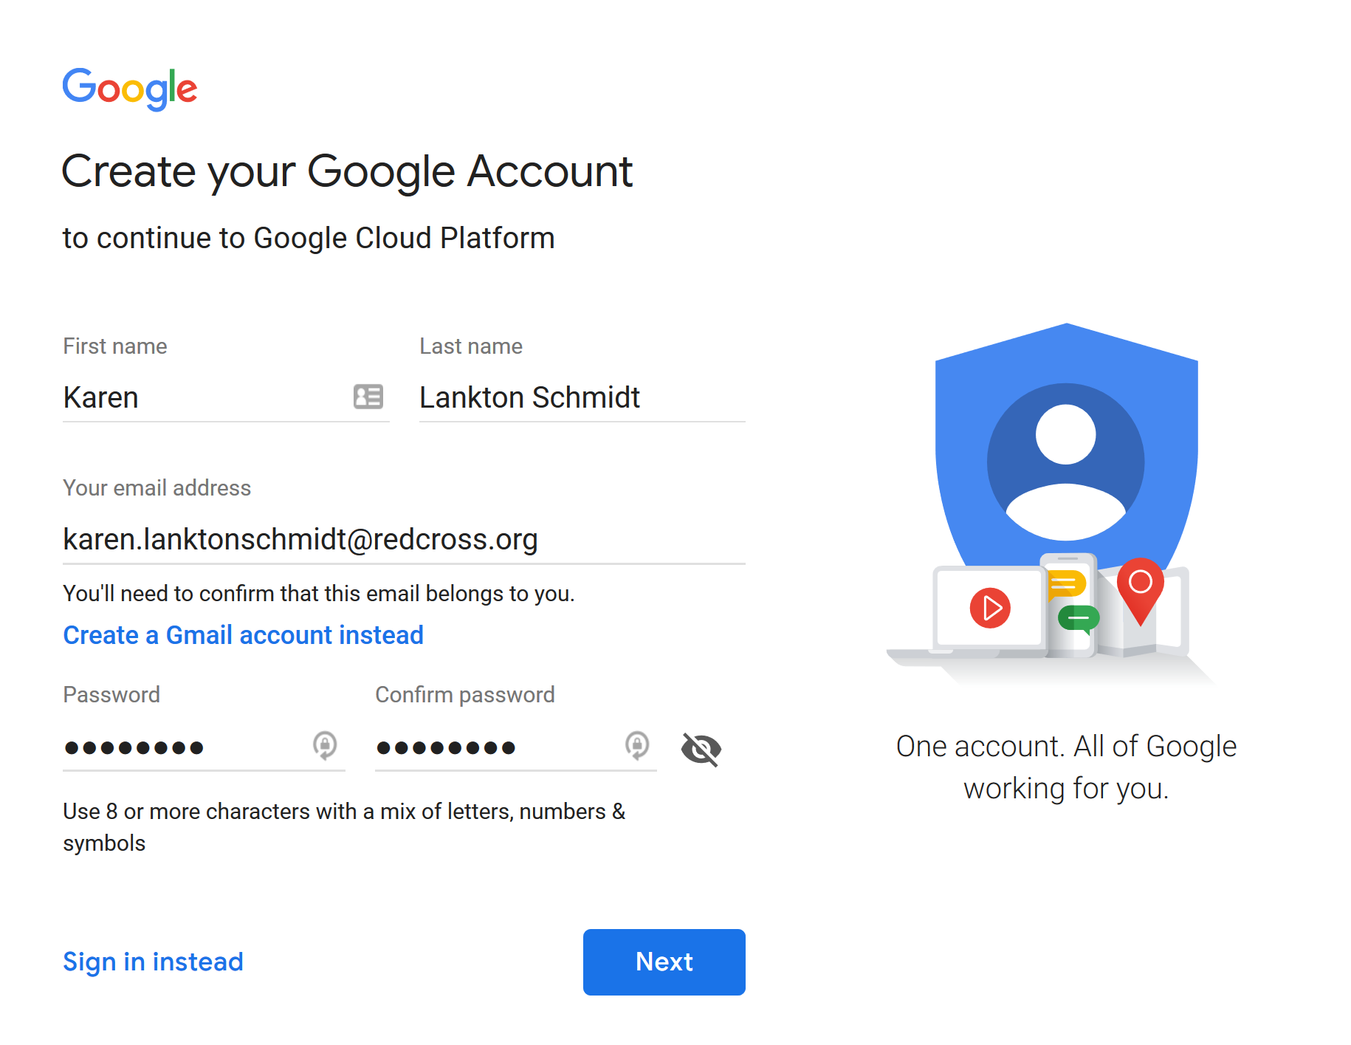
- Go to your email account and look for the email verification email from google.
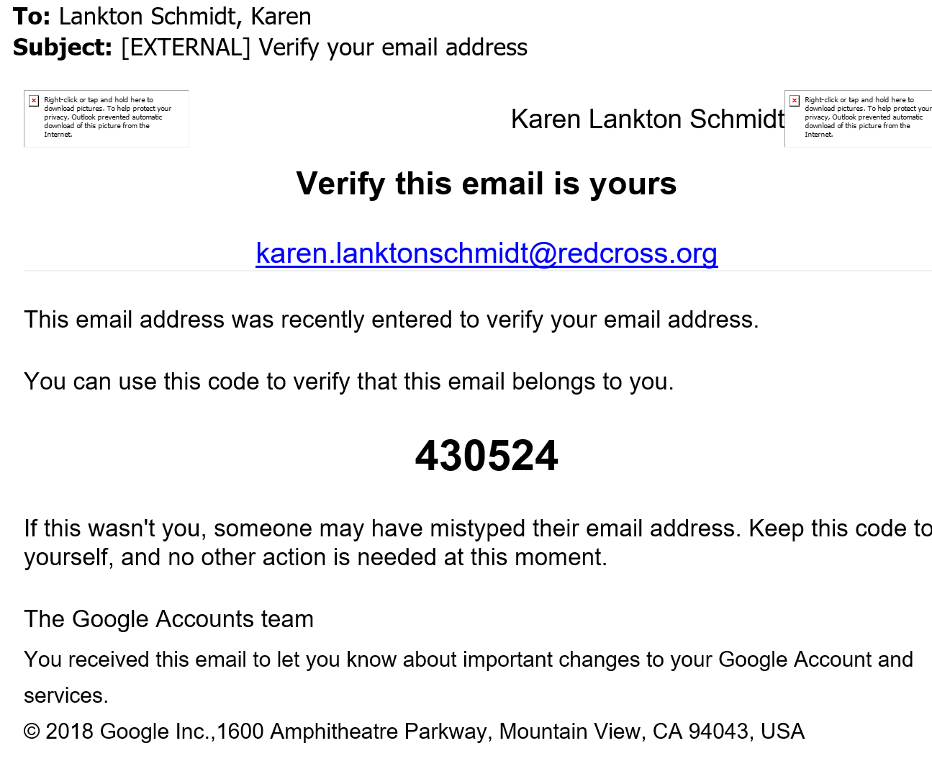
- Return to the website and fill in the verification code and select verify.
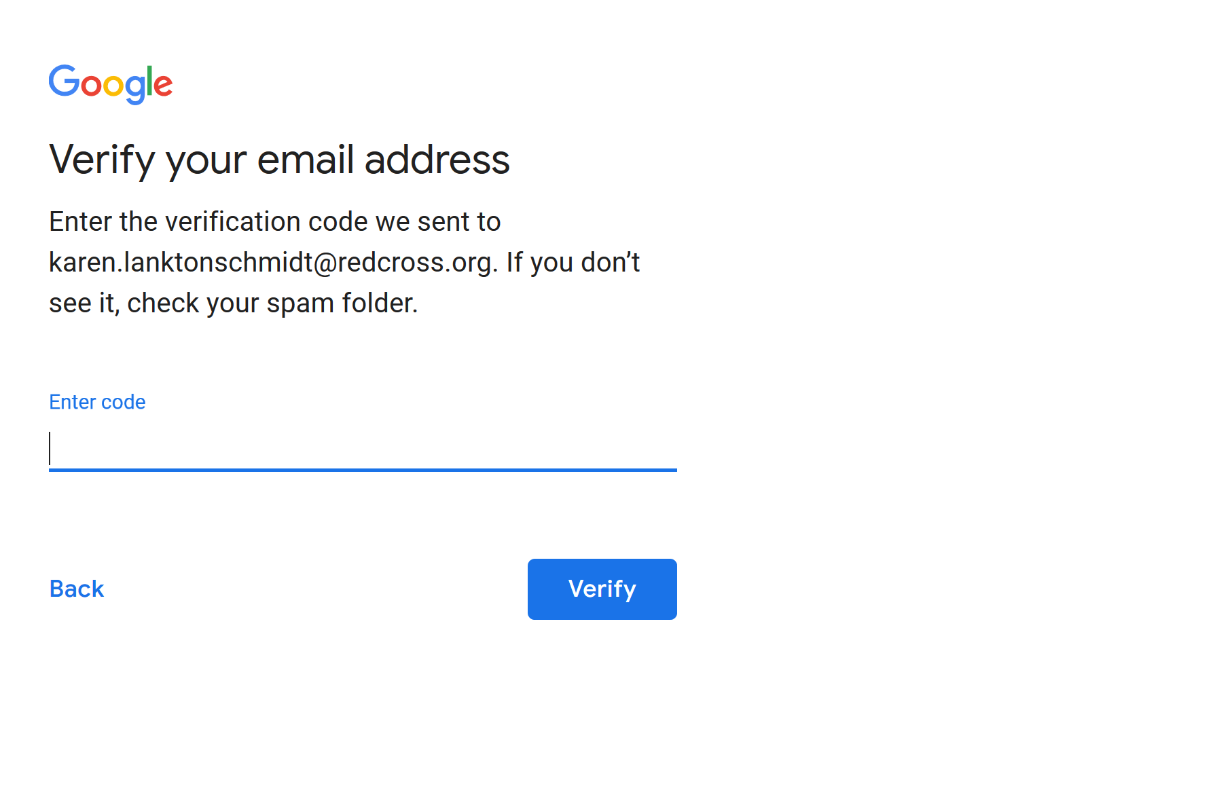
- Enter a phone number that accepts text messages. You will receive a verification text every time you go to the Google console account (for changing billing information, adding keys etc).
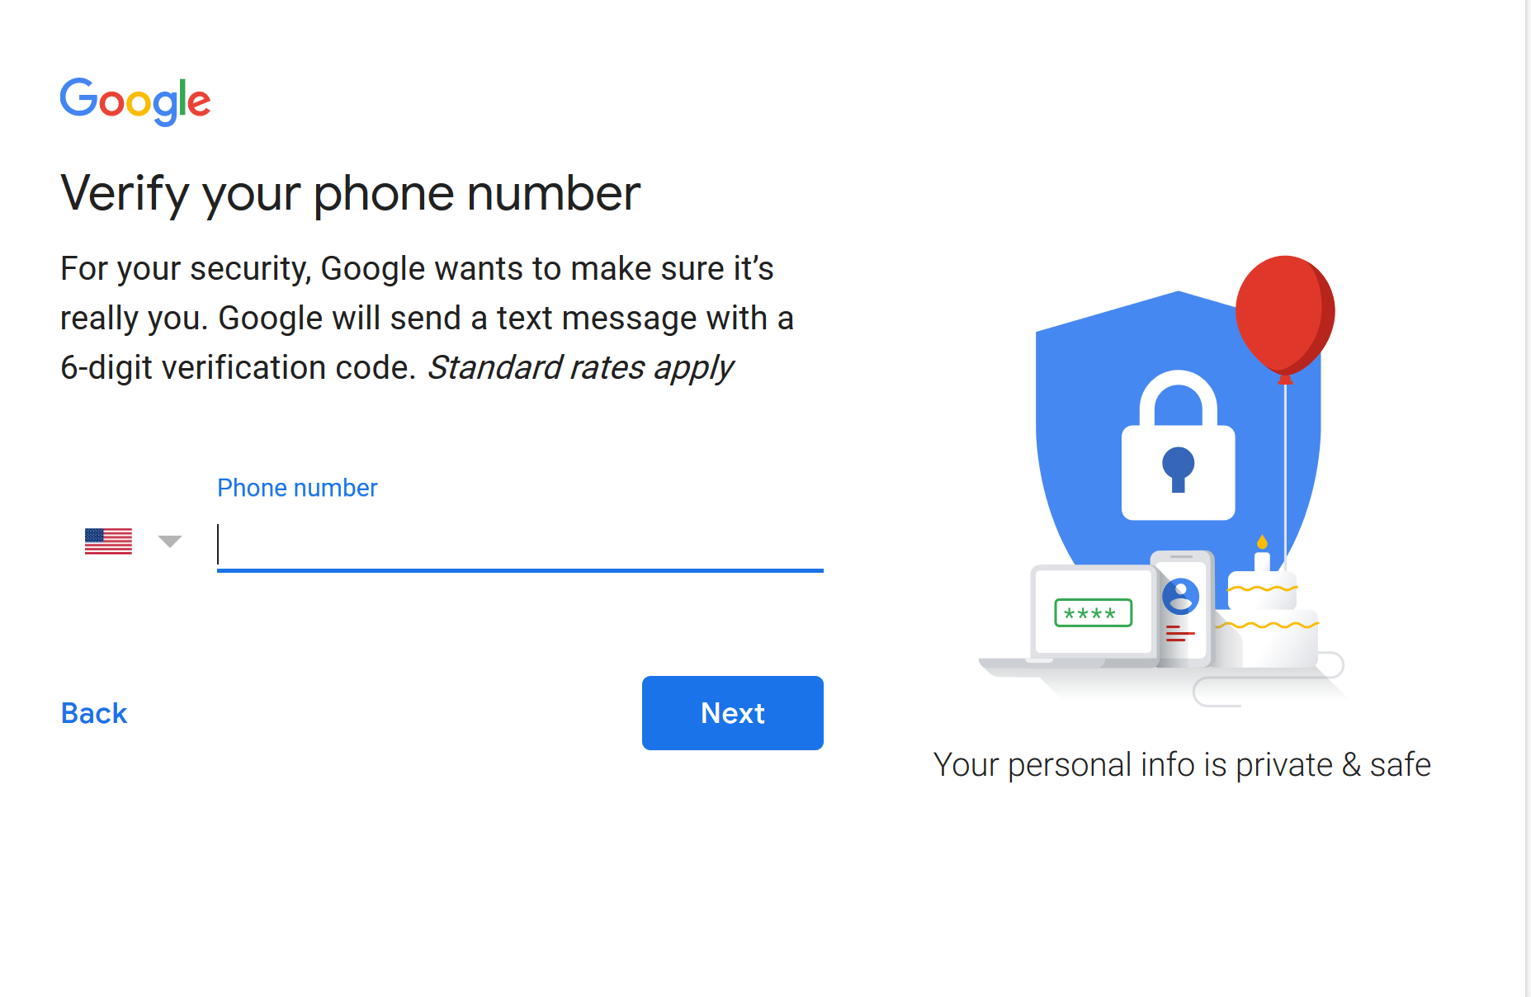
- Enter the verification code that is sent to your phone and select verify
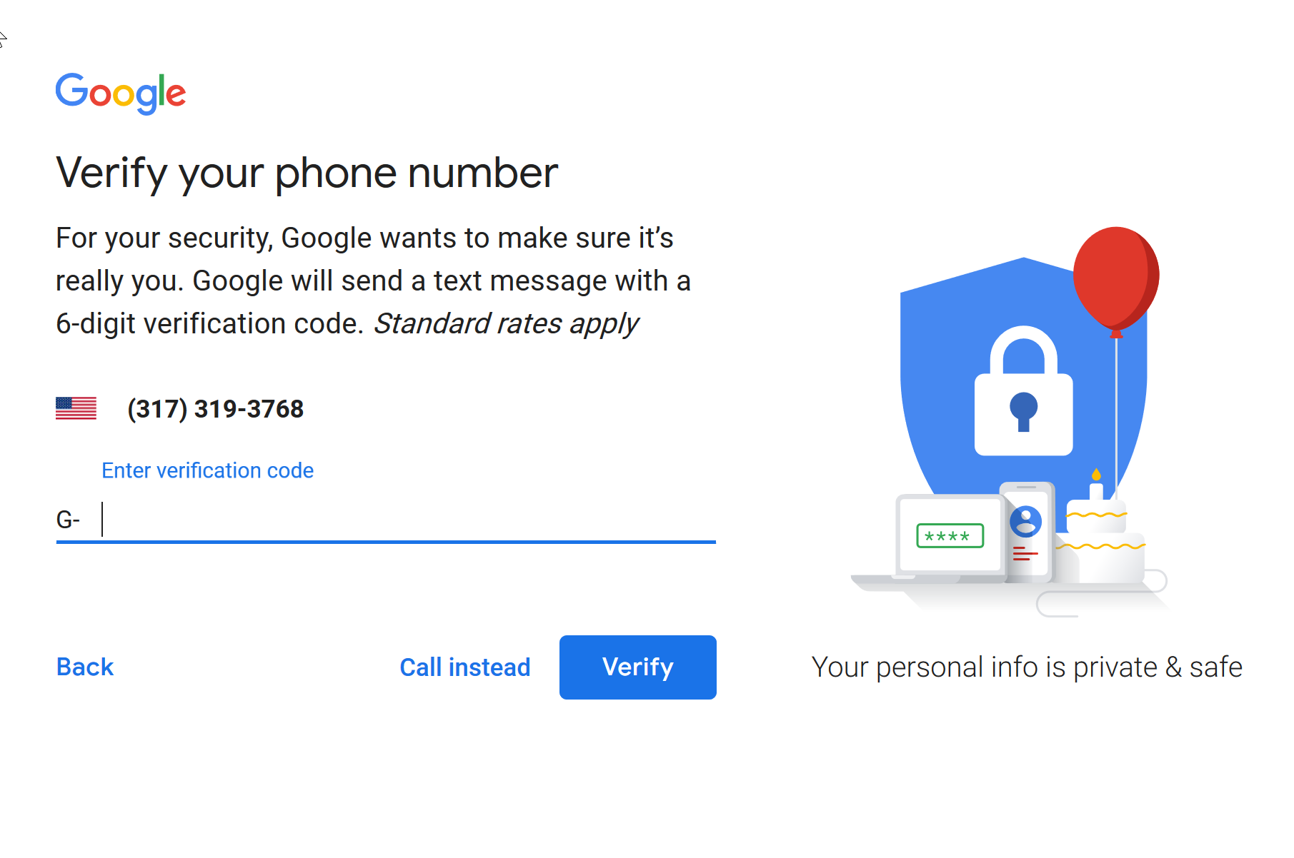
- Enter in your information and select Next
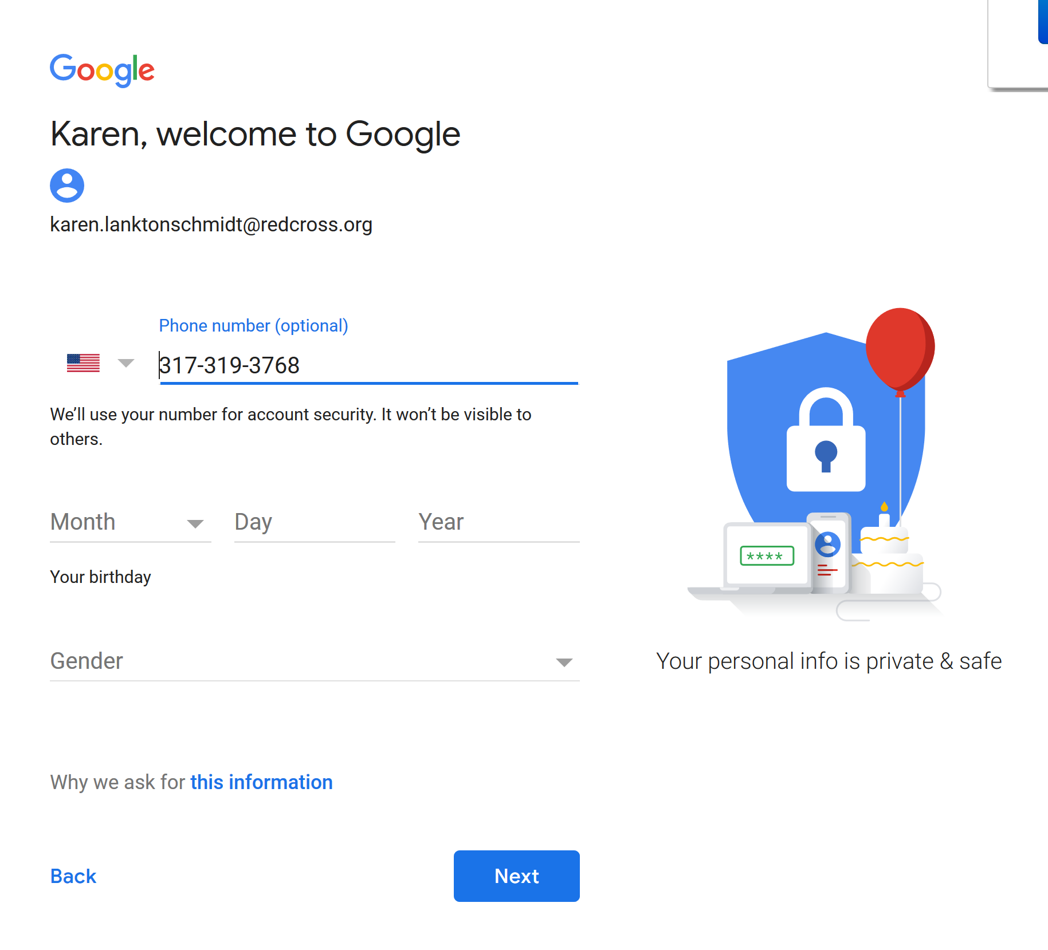
- The next dialog box allows you to link your phone number to other google services. This is not required for Geocoding. Select either skip or Yes I am in depending on your preference.
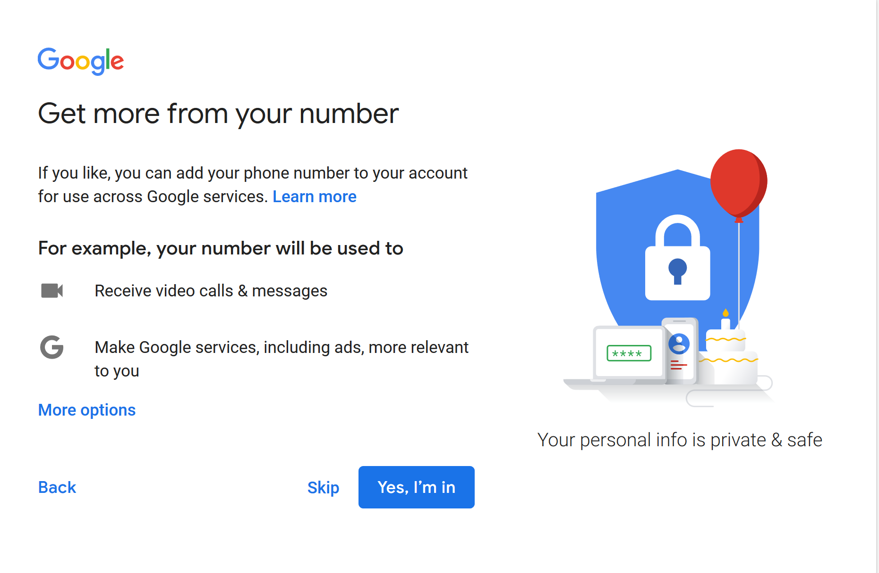
- At the Privacy and Terms dialog box, review the terms, and the more options drop down which allows you to configure privacy settings and then select I agree to continue.
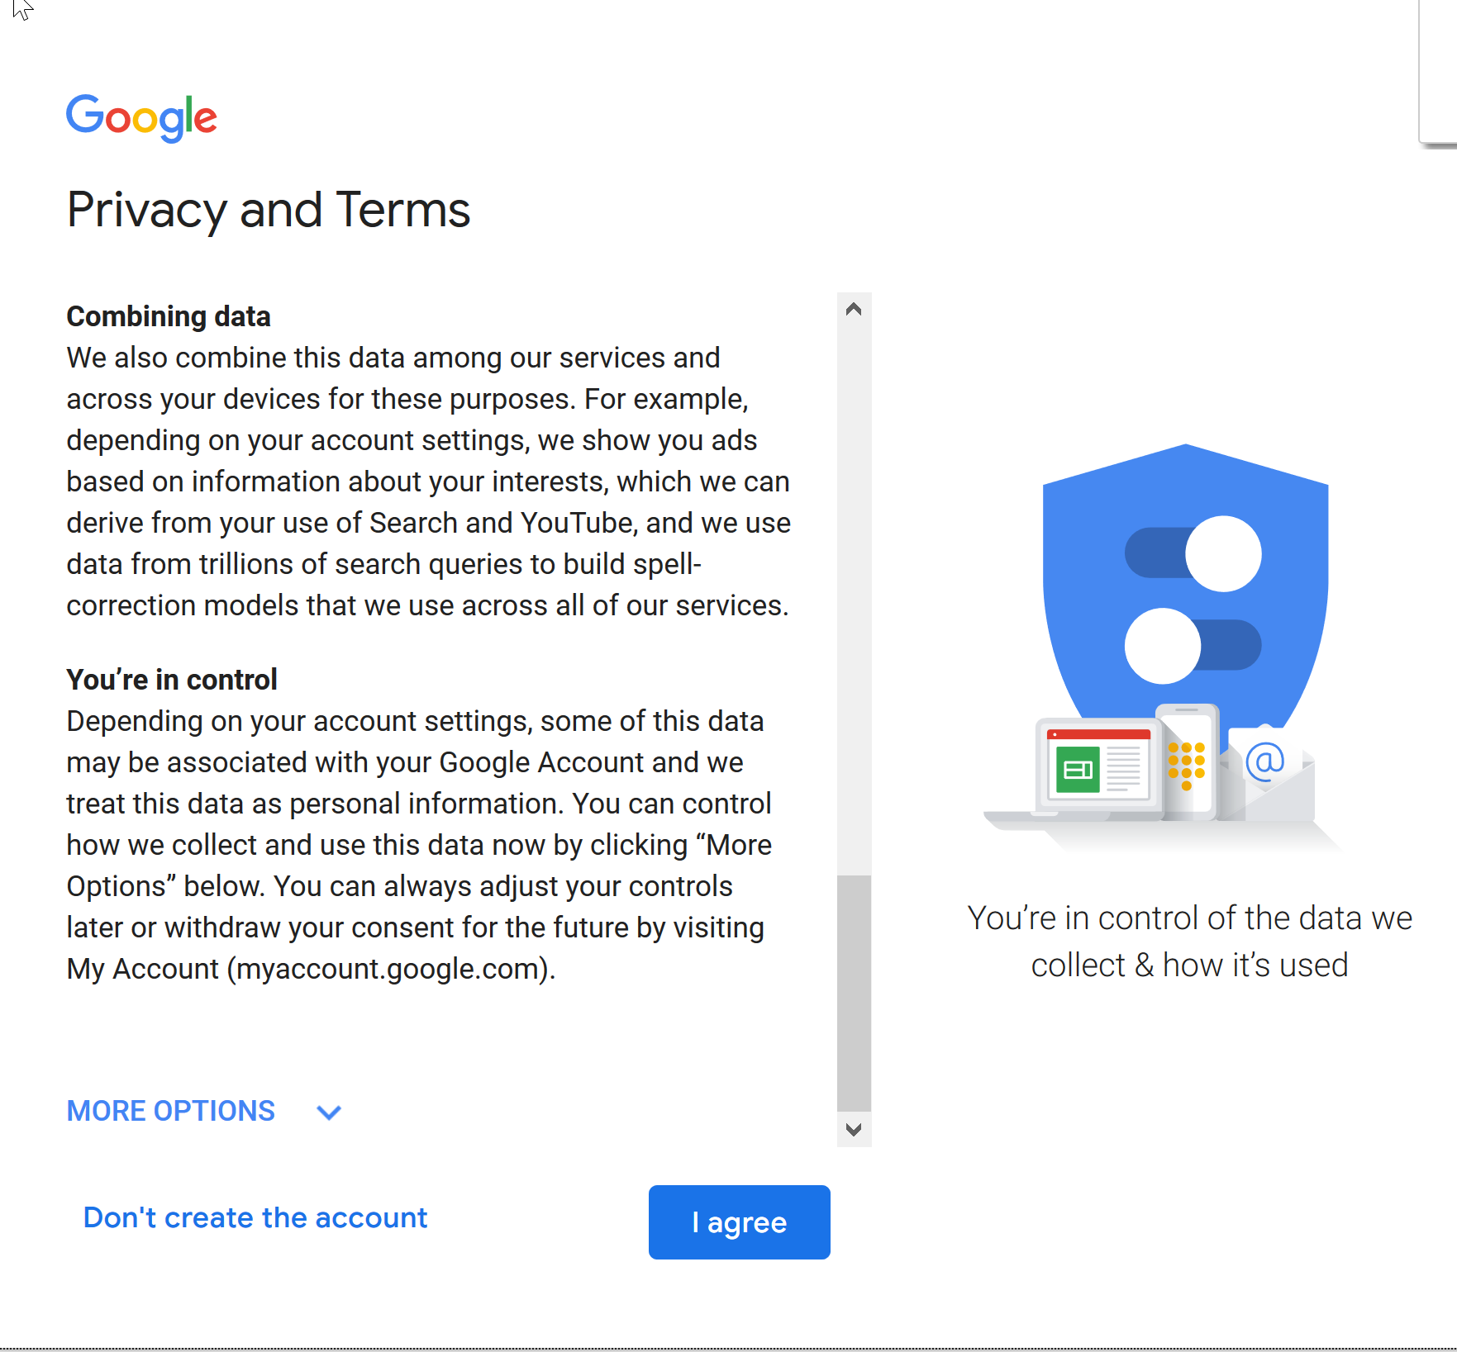
- After selecting I Agree, your account will be created and you will be signed into your account and returned to the console webpage. Select the Get Started either in the upper right or the middle of the web page.
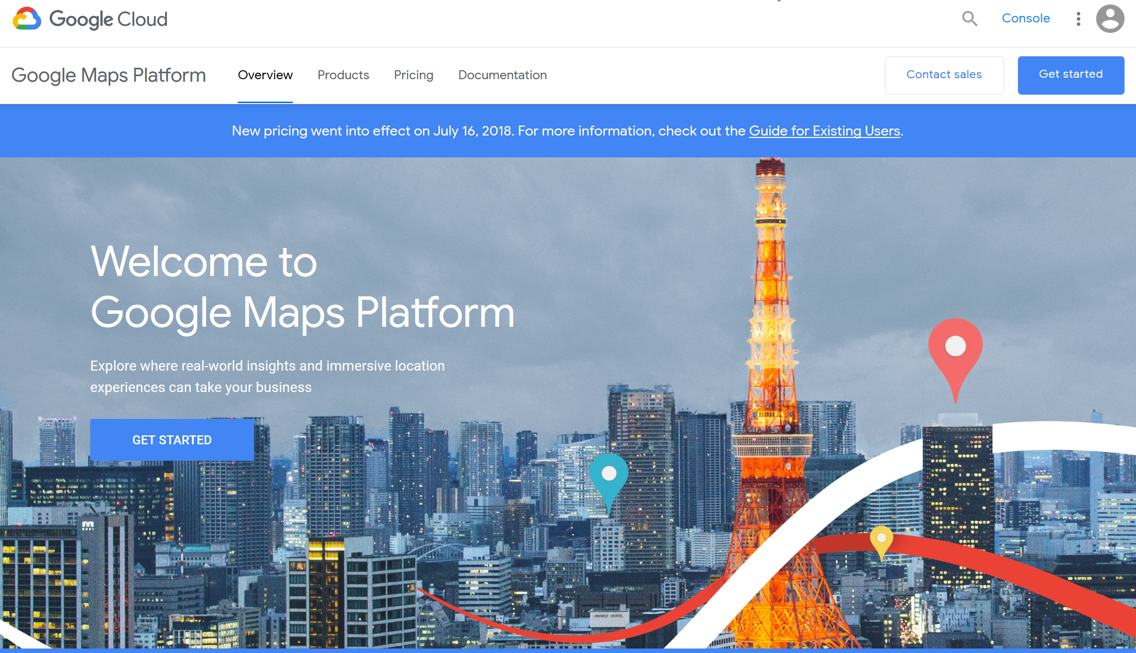
- At the Google Cloud platform site that opens select the Maps product and then continue
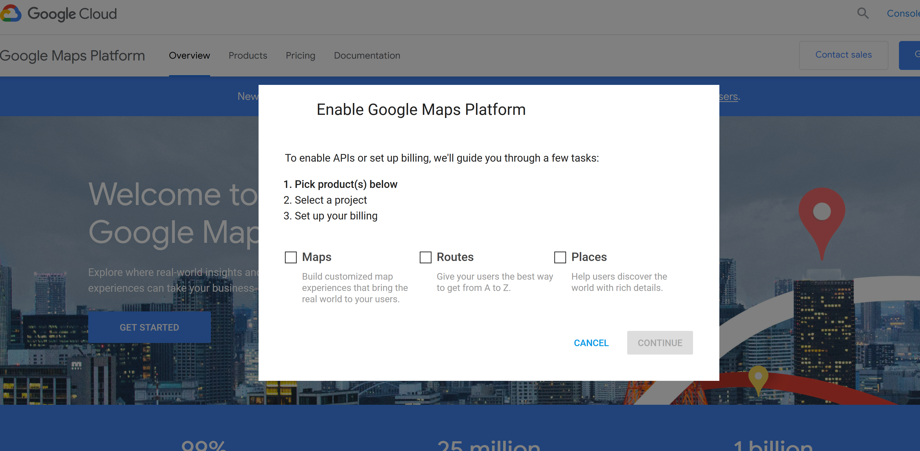
- At the dialog box, you will be setting up your project. Enter a name for the project and agree to the terms of service.
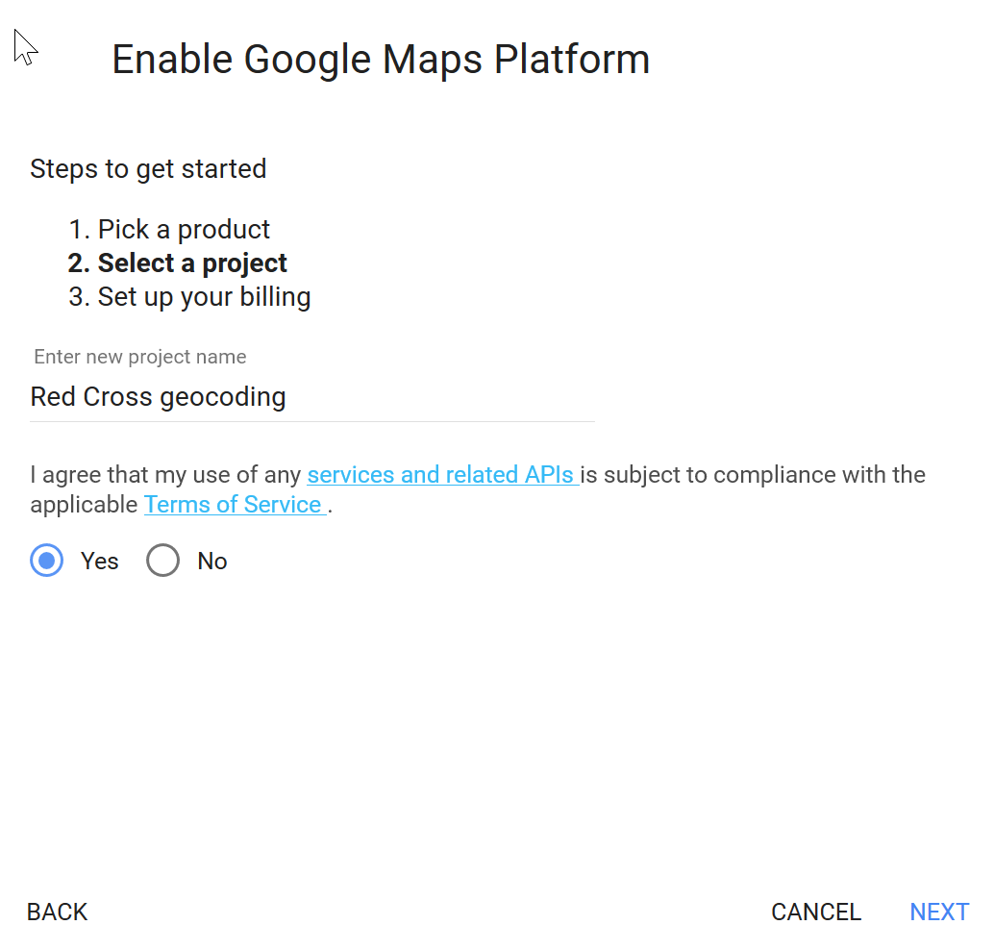

- You will be taking to the console to set up your billing information
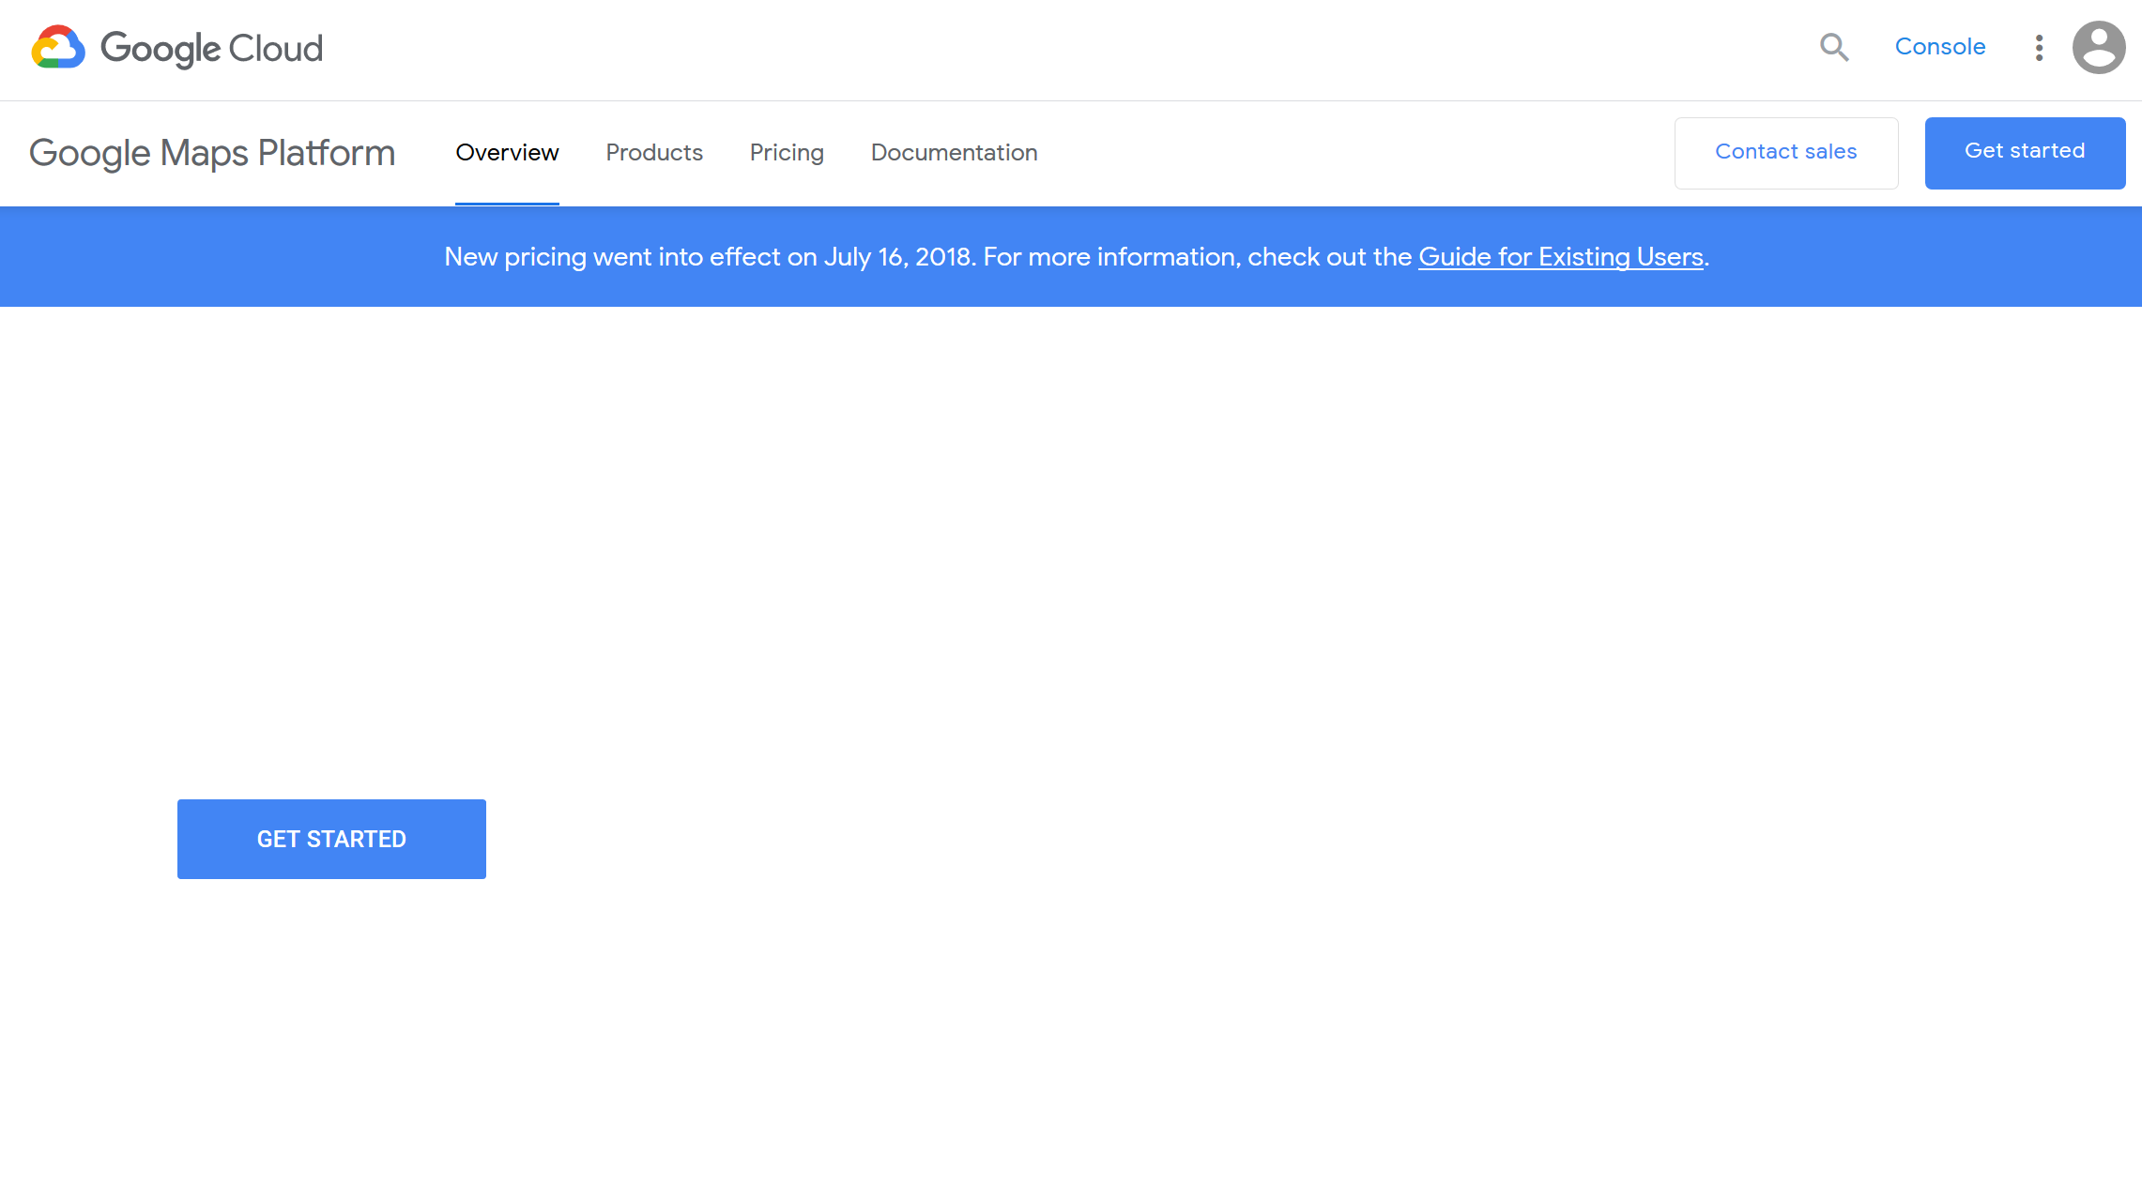
- The wizard then goes to create your billing account. Select the get started and follow the steps. This did not work properly for me in Mozilla. The wizard disappeared and I could not get it back. It took me back to the console web site. If this happens to you, Click on the hamburger in the left top corner (three horizontal lines) and select billing from the left navigation that appears.
- The following instructions are what I took after selecting Billing from the navigation – hopefully they are similar to the wizard steps.
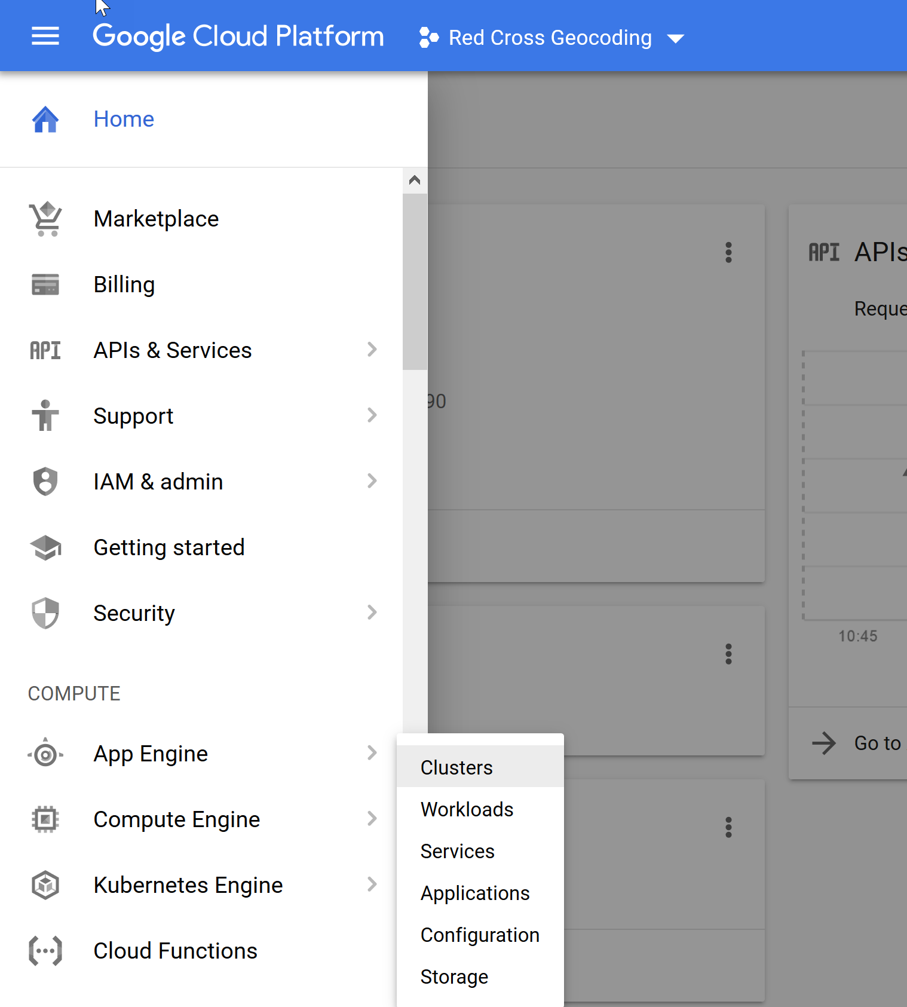
Billing
Hamburger
- This window will open up. If you have not yet set up a billing account, select Manage billing accounts. Otherwise you can select Link a billing account if you already have one.
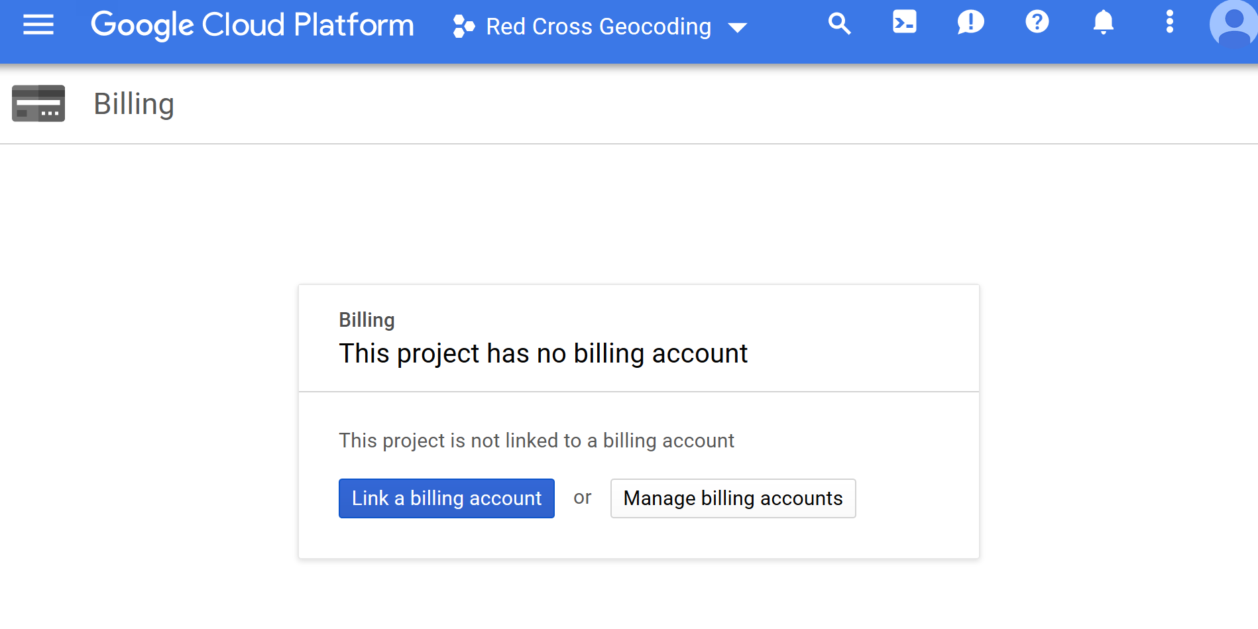
- From the Manage Billing site, select Add billing account
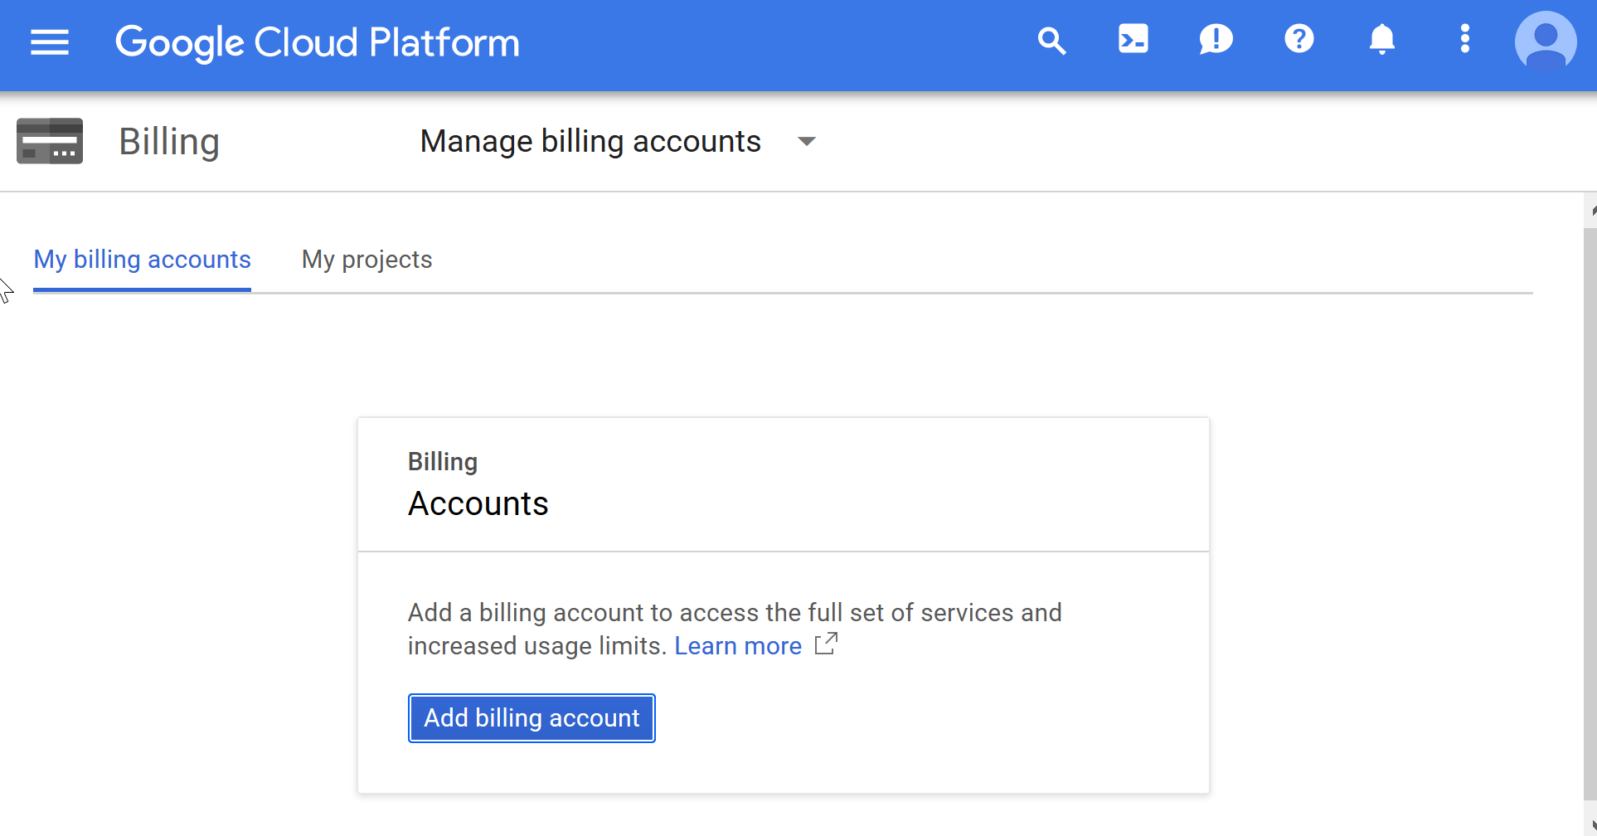
- Currently they are offering a free $300 account. You still need to add a credit card to the account but the account is free for the first $300 for up to a year.
Key points about the free account:
- You need to upgrade you account or it will no longer work after the free offer expires even though you have configured a credit card to work with it. I would upgrade as soon as you create your account or a year from now you will be wondering what happened.
- You are only allowed to take this offer once but they will have you set it up every time. If you have already used it, your key will not work properly. You will need to upgrade your account immediately.
- Upgrading your account – when you sign in to google console a banner will pop up with the opportunity to upgrade your account. You may need to refresh your browser or sign out and back in to see this banner. Select Upgrade when you see it.
- On the free offer dialog, change the account type to personal. The window will change slightly. Complete the requested information and agree to the terms to continue.
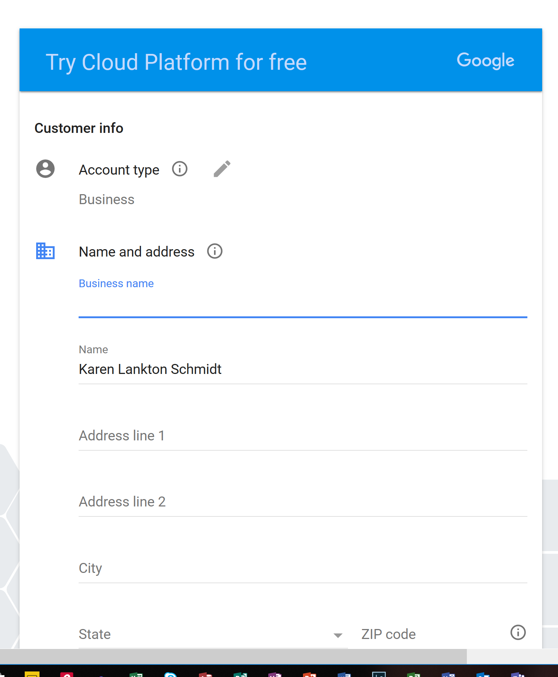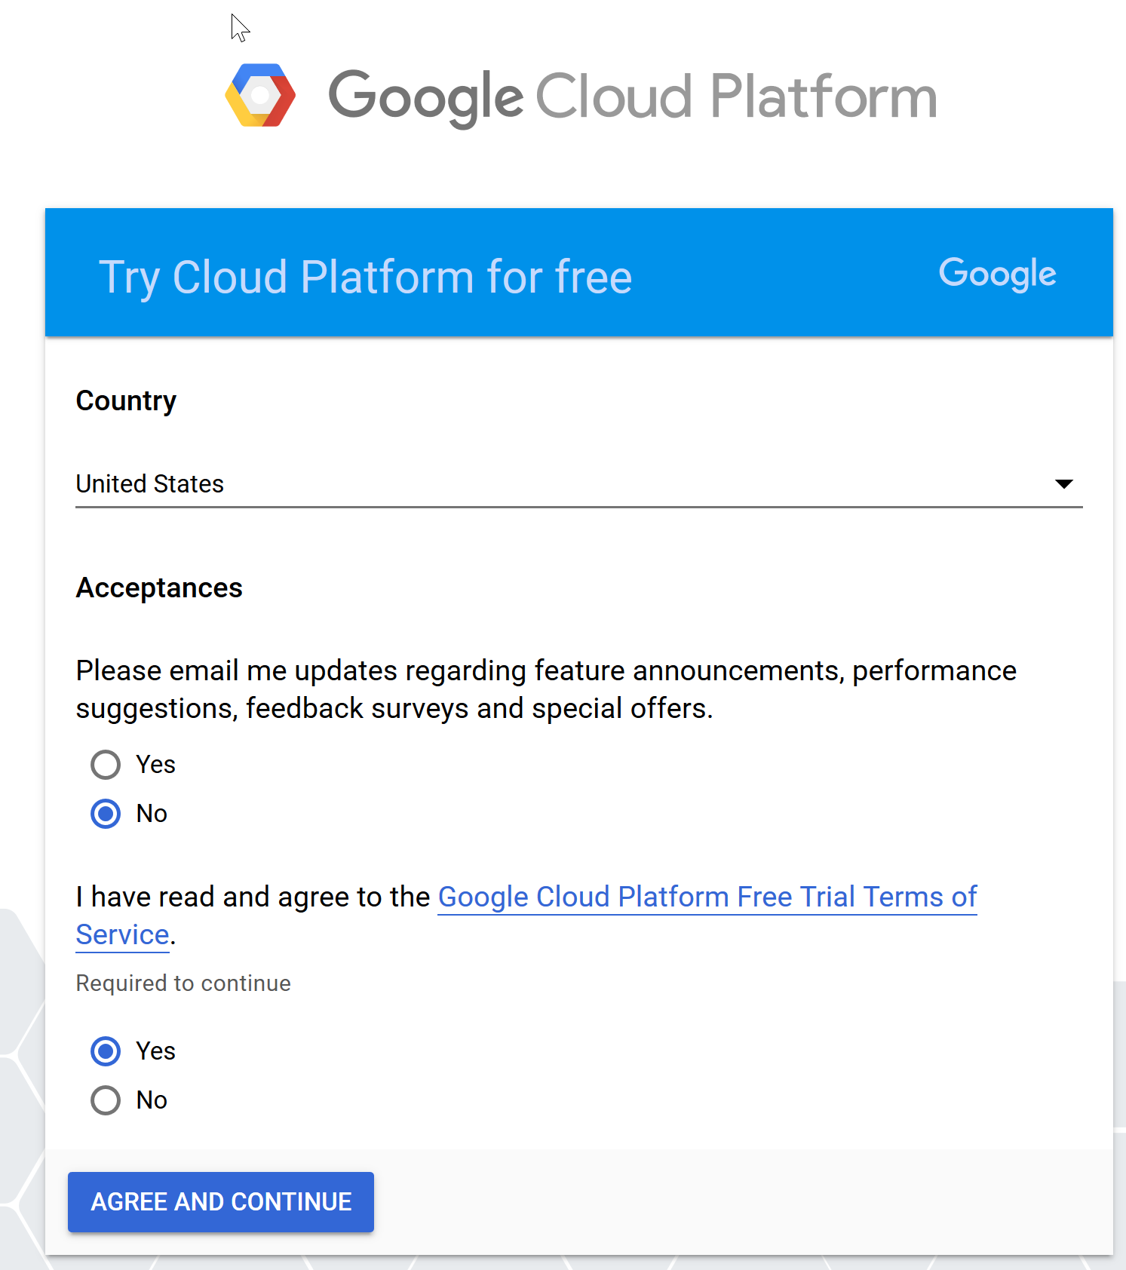
Change Account type to personal
- You will then need to verify your payment information. Select Proceed to Verification. In the verification process you may be required to upload a picture of your ID and credit card
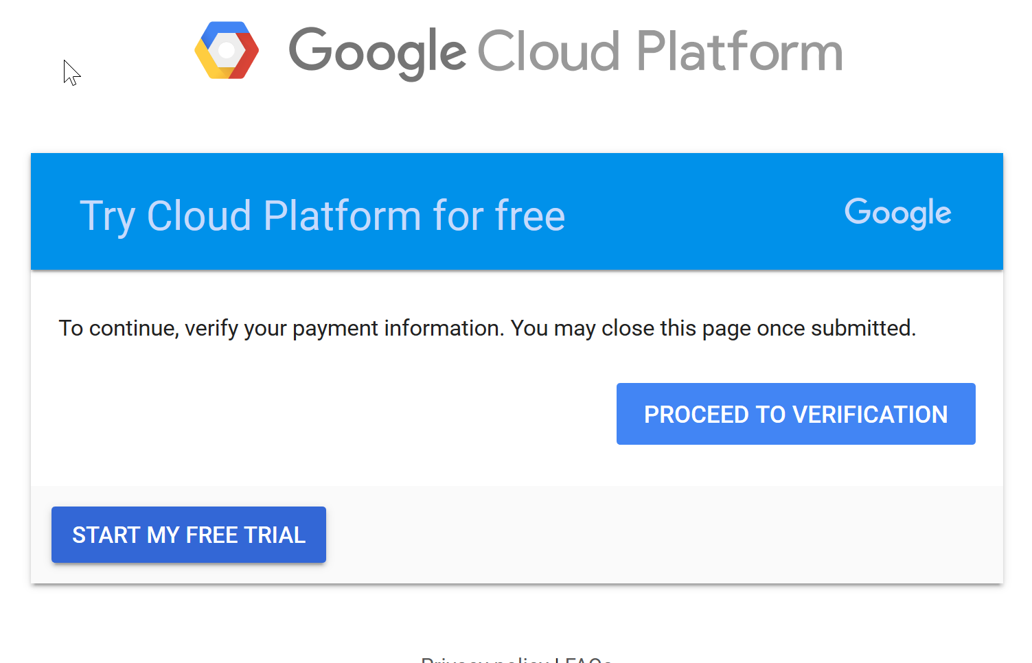
- Once your billing is set up, select the hamburger again and chose APIs and services. The following window will open. Click Select project, and if you don’t have a project set up it will take you to a screen to create a project.
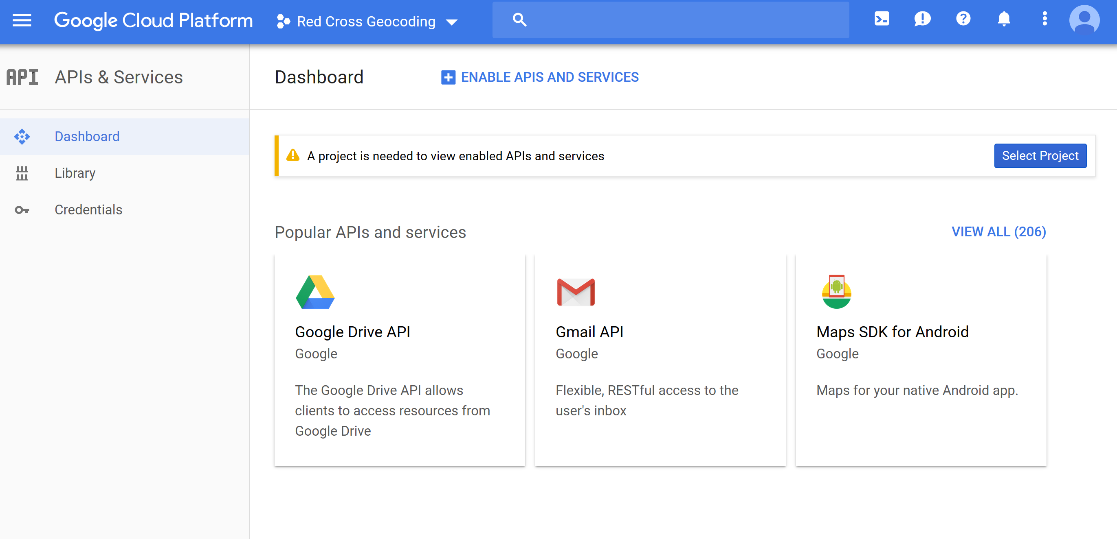
- The Dashboard will appear with some APIS showing up at the bottom. You want to enable the Geocoding API. If this does not appear in the list, select Enable APIs and services at the top of the page
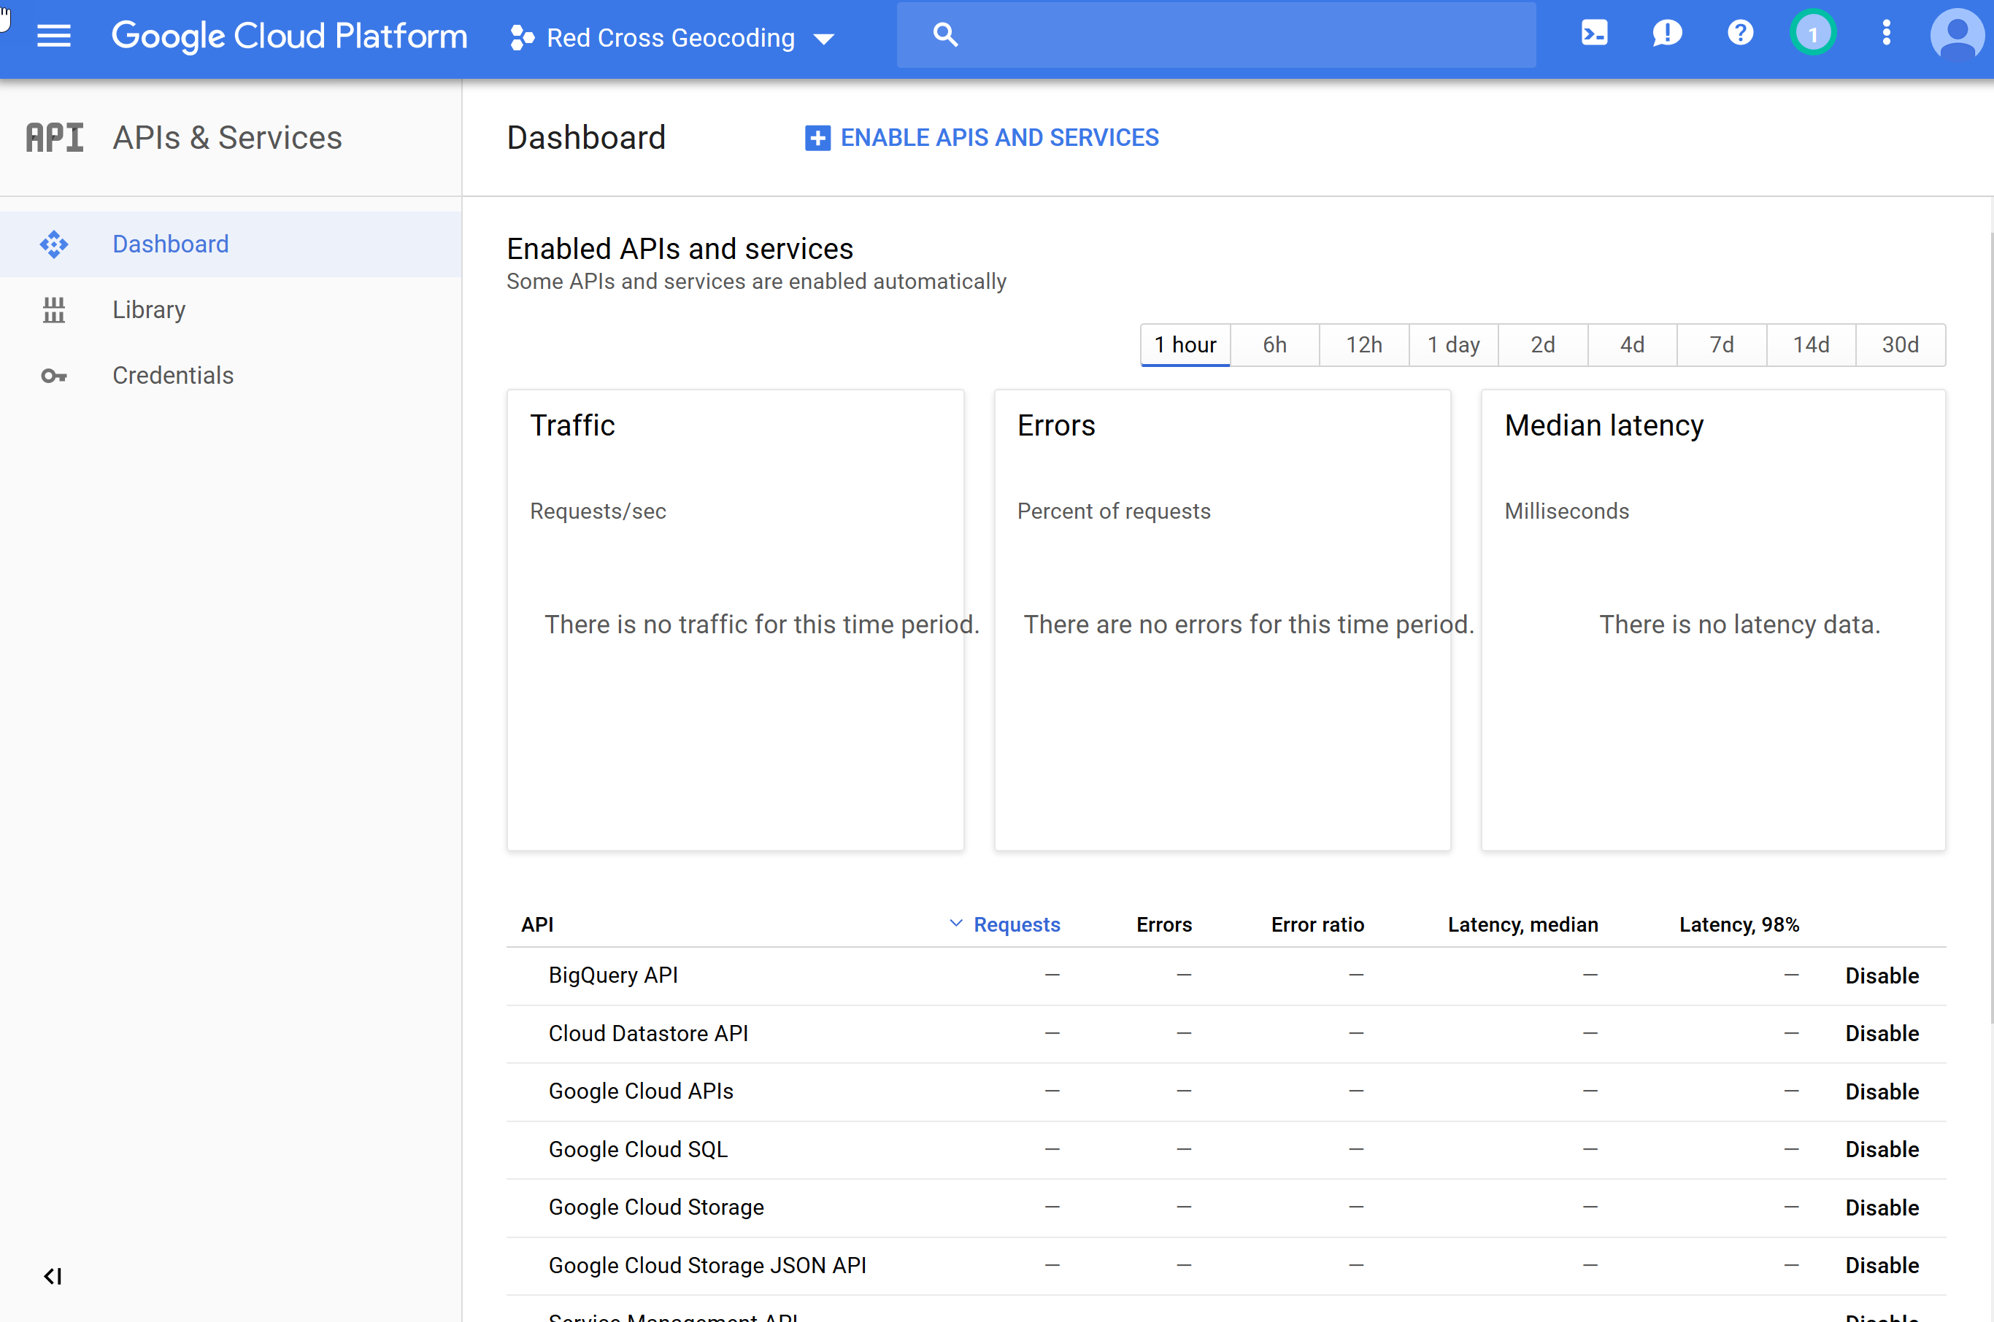
Select Enable APIs and Services to add the geocoding api
Look for Geocoding API here
- In the search window, enter Geocoding API
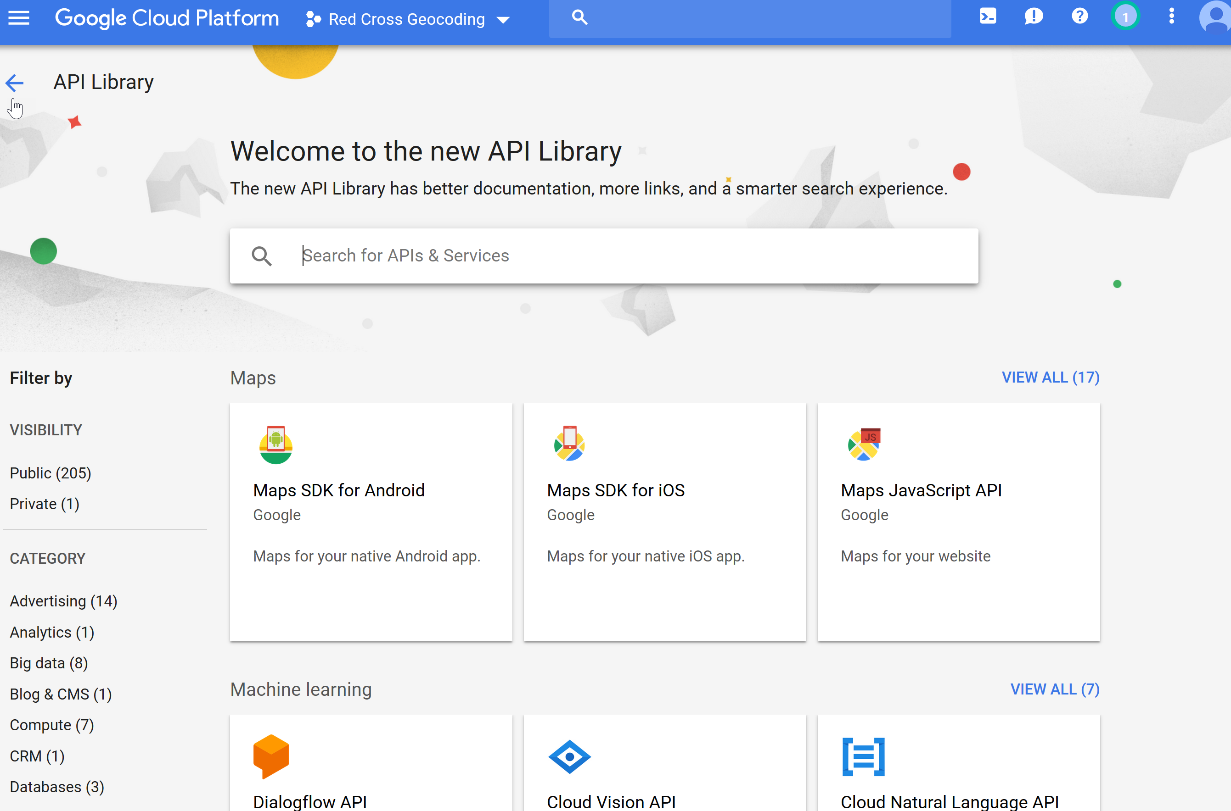
Search for Geocoding API
- Select the Geocoding API from the search results, Select enable at the next dialog and you will now see it in the list of apis.
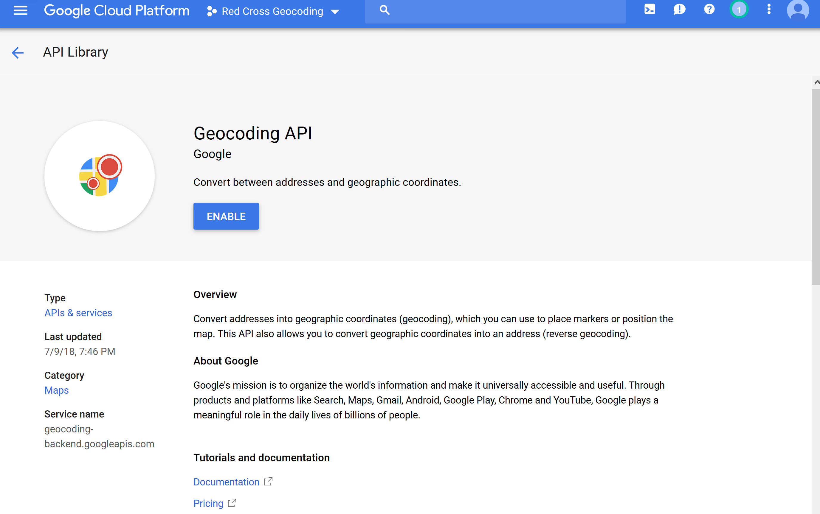
- A confirmation will appear.
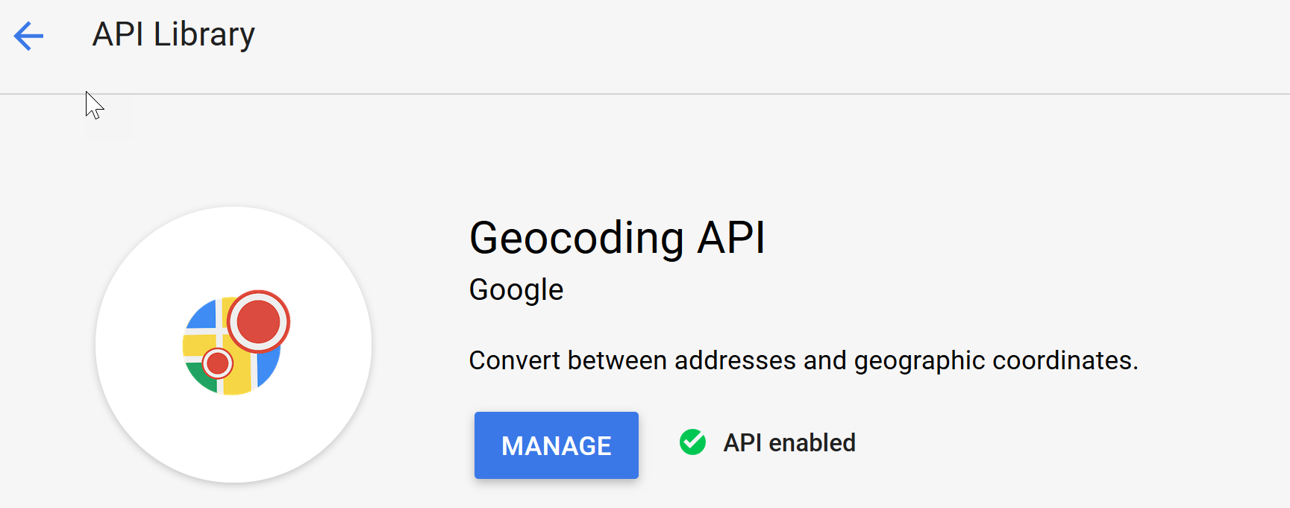
- Return to the API and services area. You will now see the Geocoding API in the list of APIs
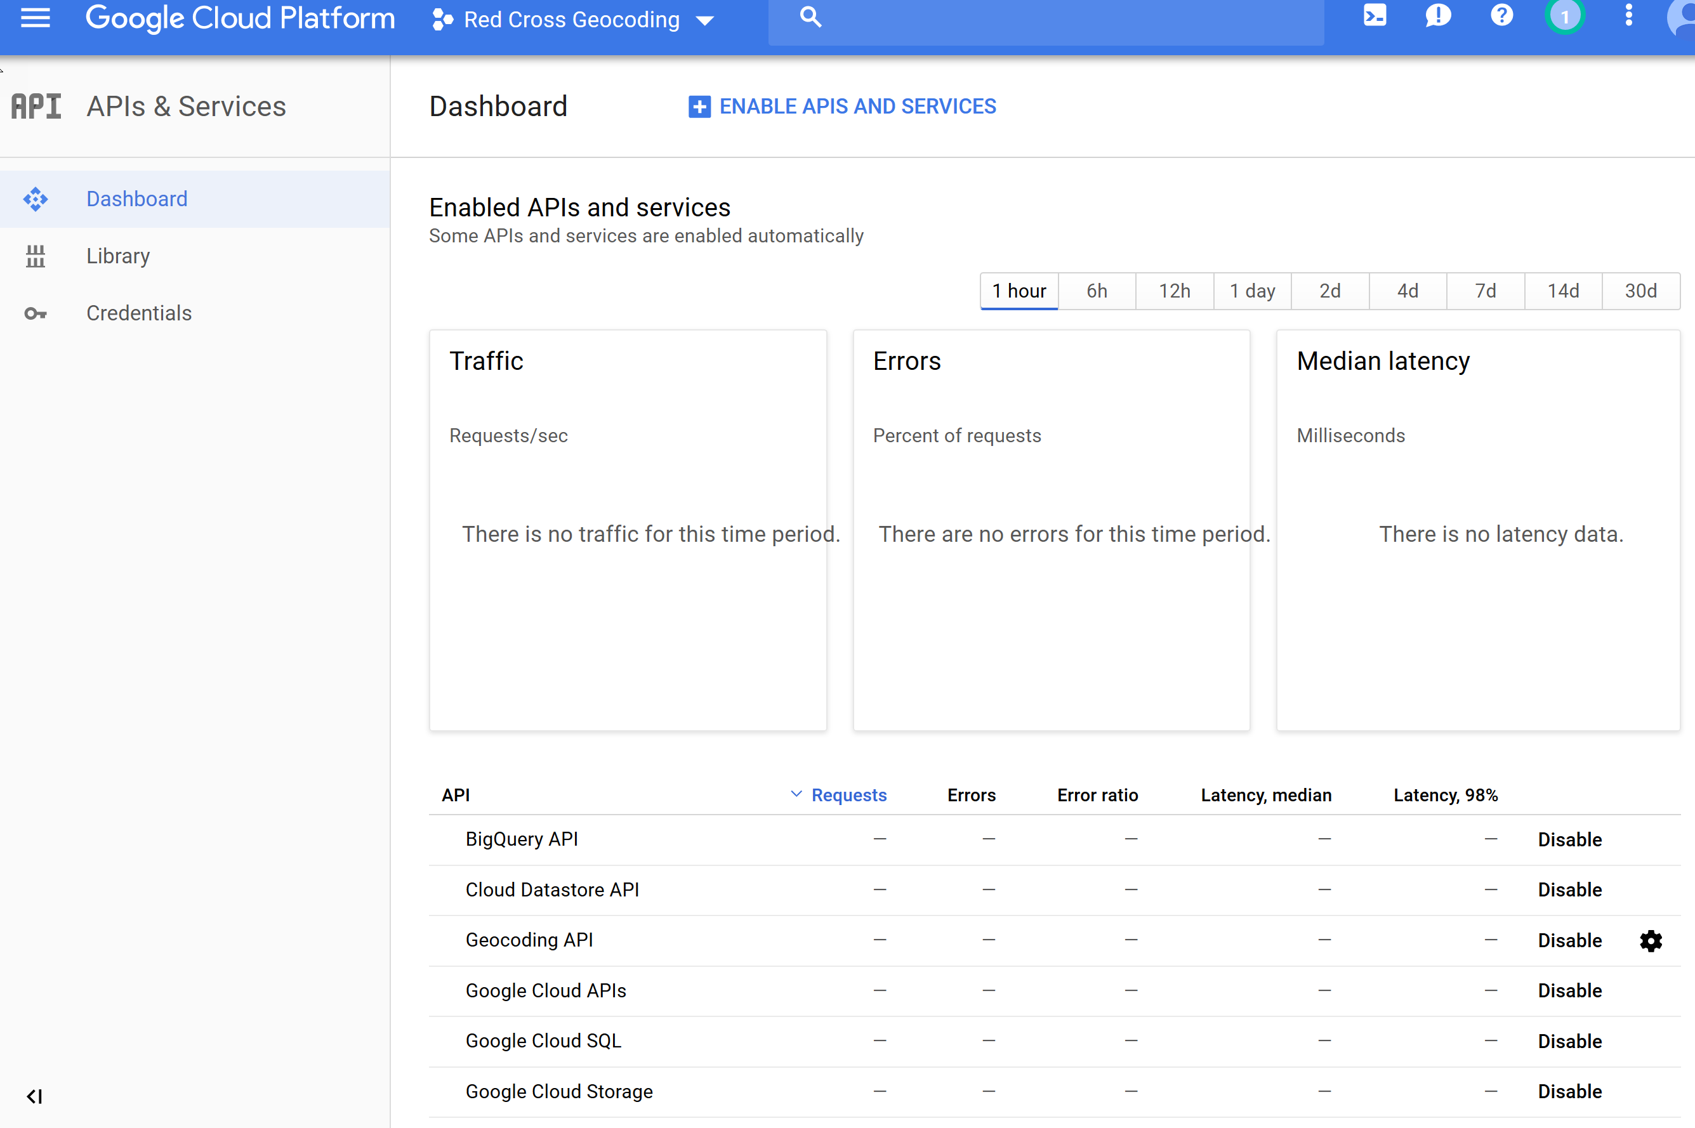
- From the menu on the left, select Credentials and then select API key from the Create Credentials drop down menu
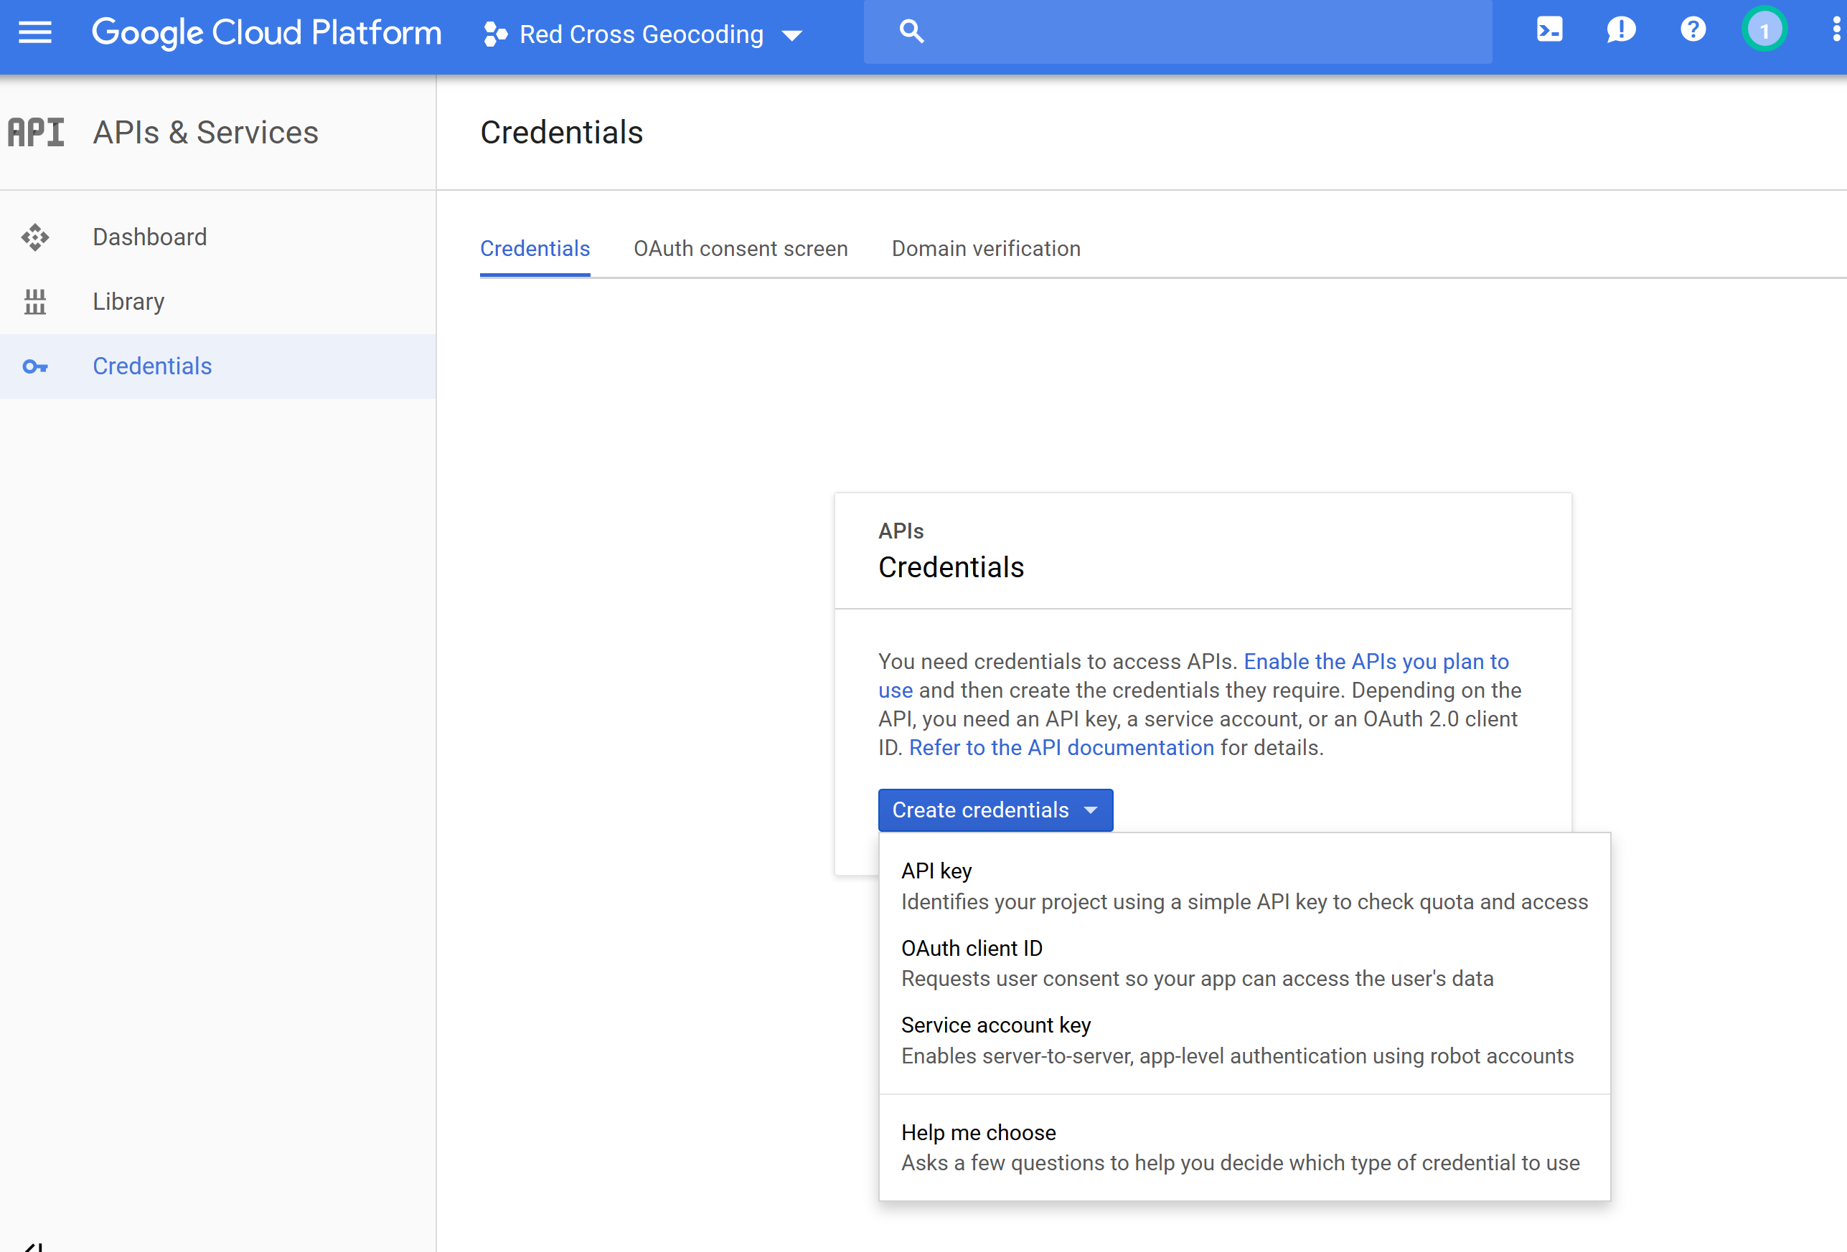
- At the next dialog copy your API key. This will be used on the geocoding website to authorize the geocoding. Your account should now be set up for geocoding.
